Day 32 –Task MongoDB- Day -2 : Database - MongoDB

1.Find all the topics and tasks which are thought in the month of October

Collection : topics

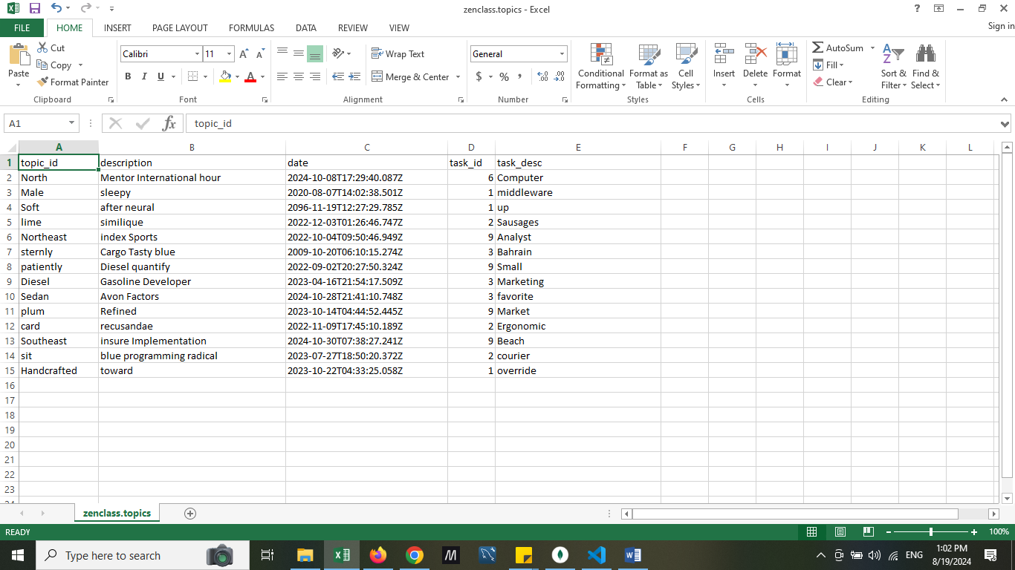

Query:

*db.topics.aggregate (*

*[*

*{*

*$addFields:*

*{*

*month: {$month:"$date" }*

*}*

*},*

*{*

*$match:{month:10}*

*},*

*{*

*$project:{*

*topic_id:1,*

*description:1,*

*task_id:1,*

*task_desc:1,*

*_id:0,*

*date:1*

*}*

*}*

*]);*

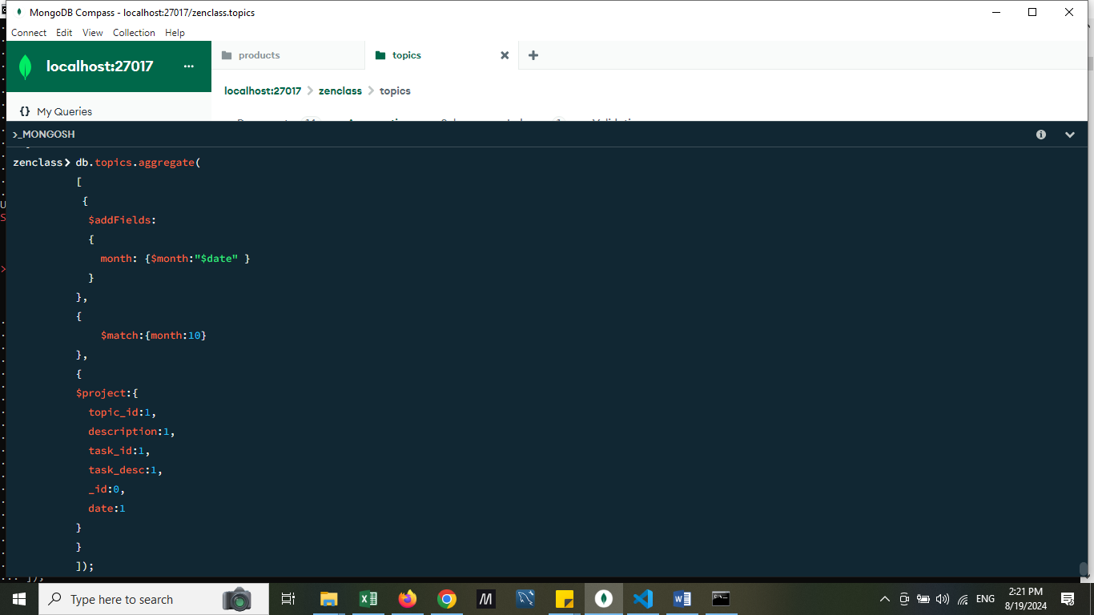

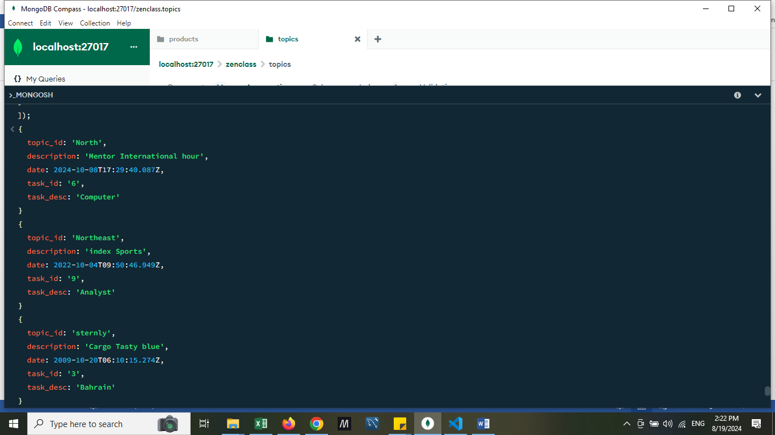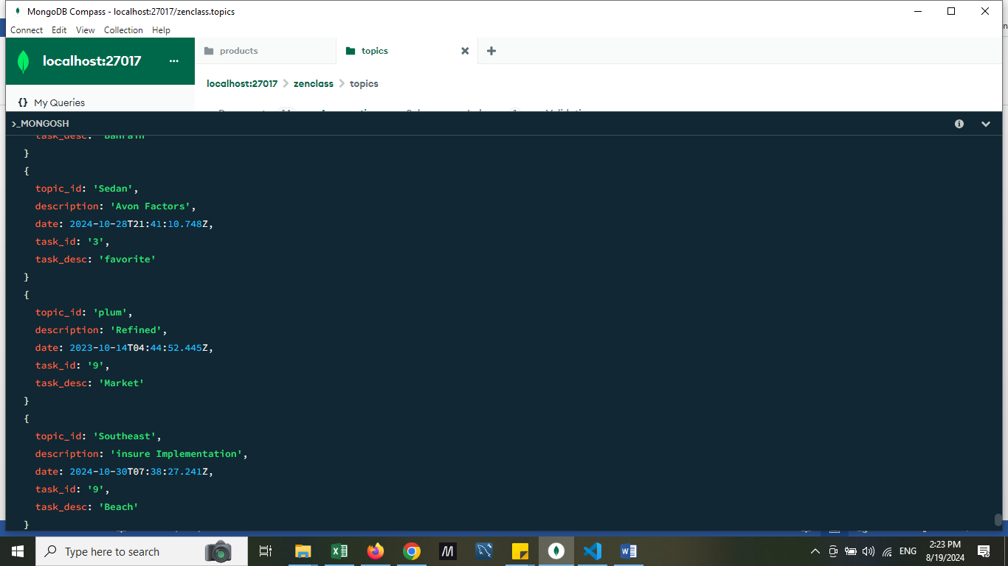

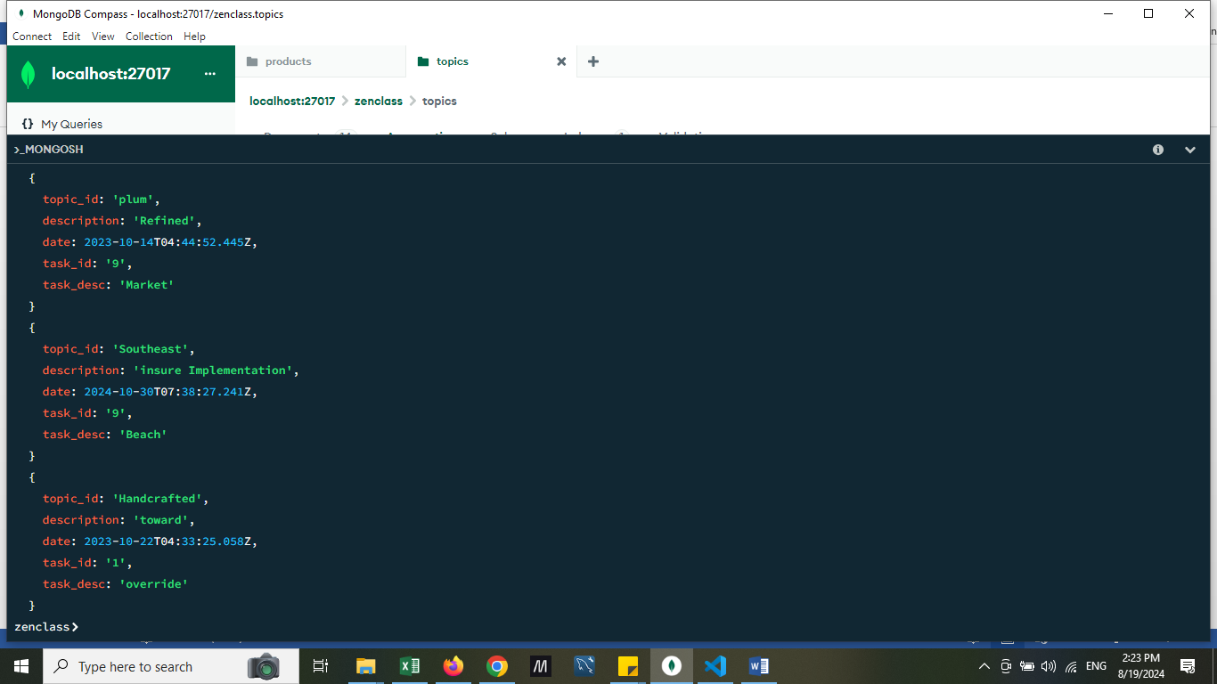

2) Find all the company drives which appeared between 15 oct-2020 and 31-oct-2020

Collection: Company drives

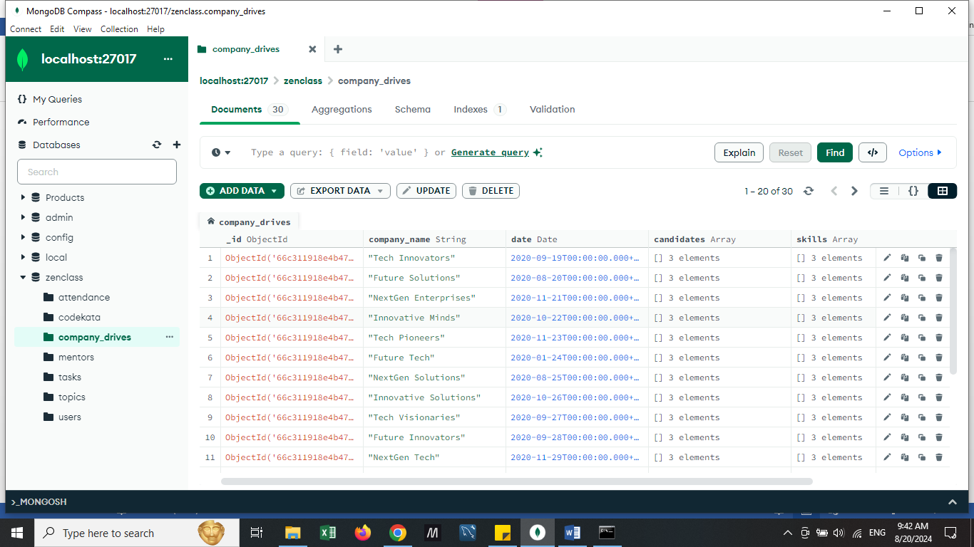

Query:

*db.company_drives.find(*

*{date:*

*{$gte:ISODate('2020-10-15'),*

*$lte:ISODate('2020-10-31')}*

*},*

*{_id:0,company_name:1,date:1}*

*);*

Results:

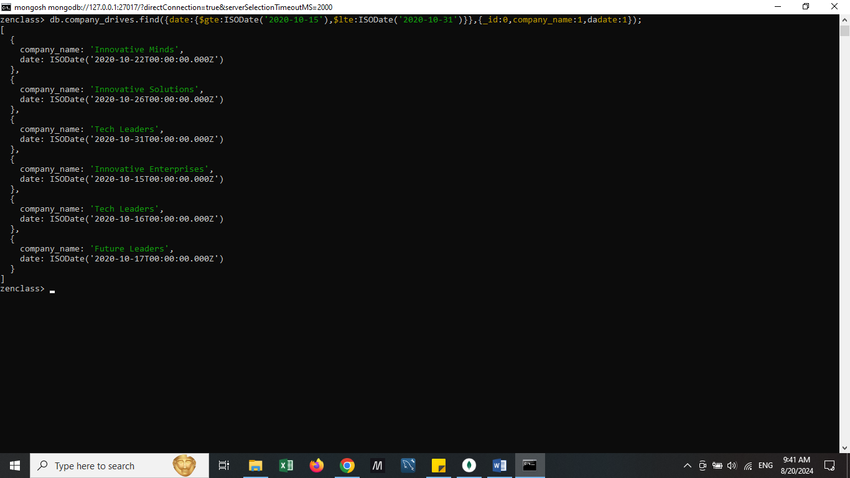

3) Find all the company drives and students who are appeared for the placement.

Query:

*db.company_drives.find({},{_id:0,company_name:1,date:1,candidates:1});*

Results:

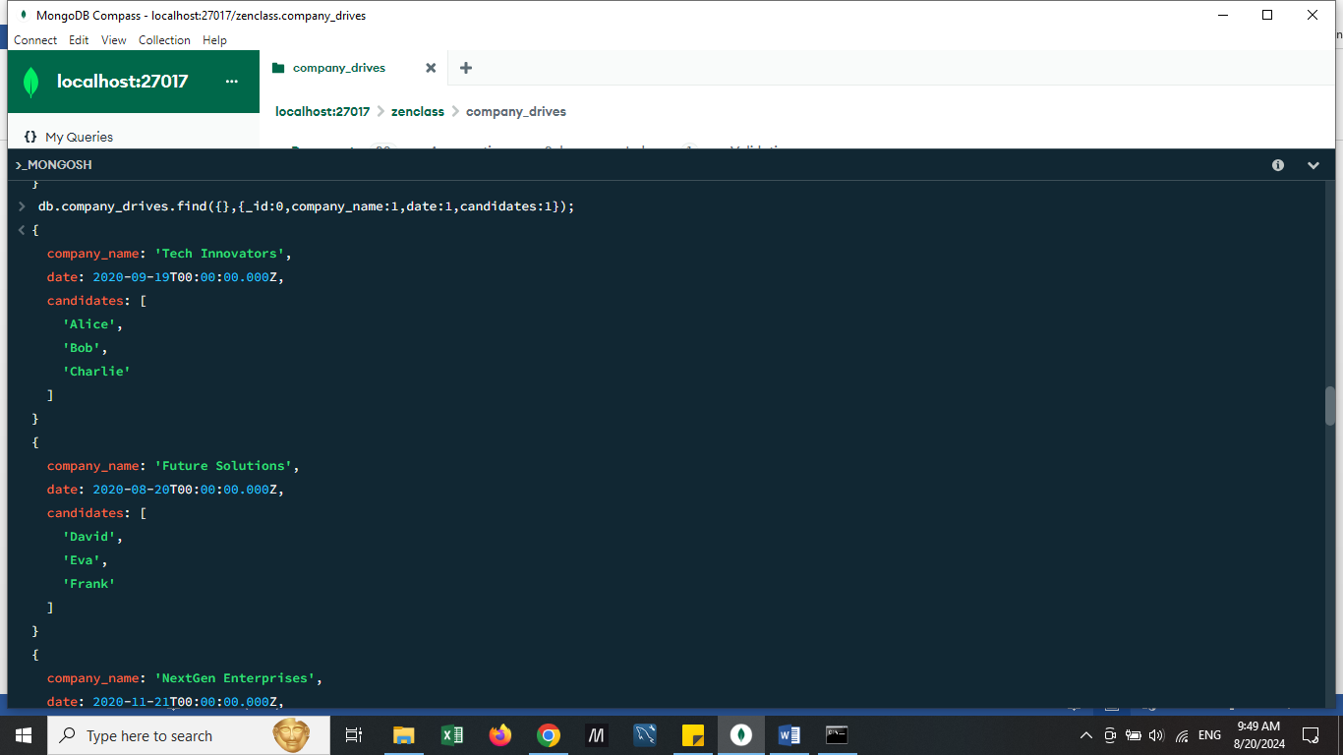 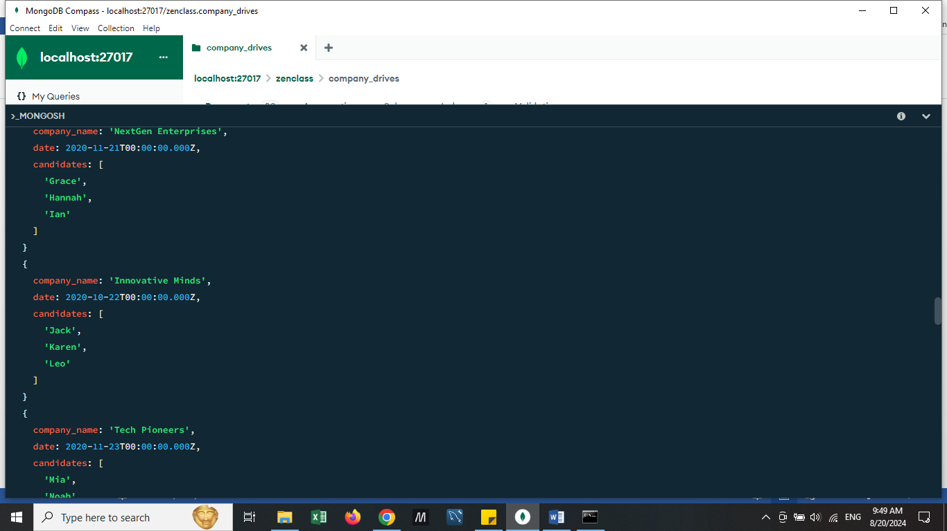 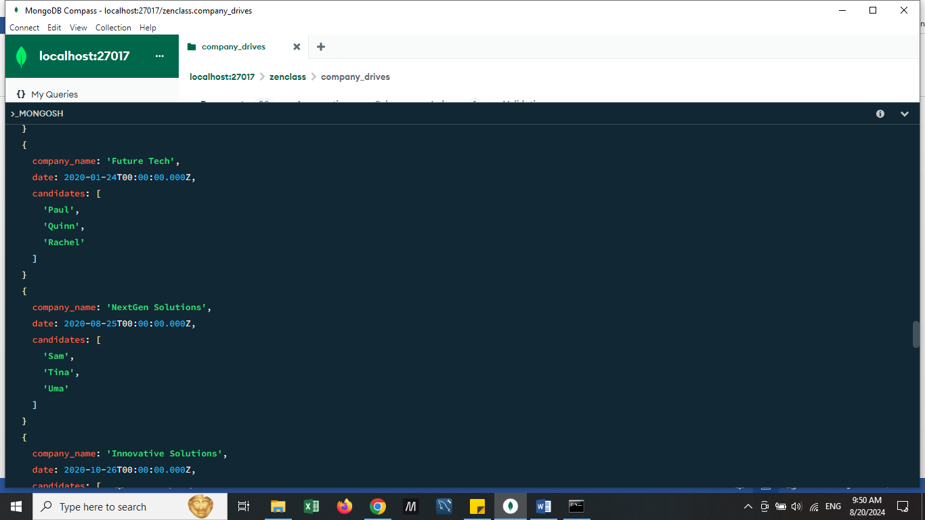 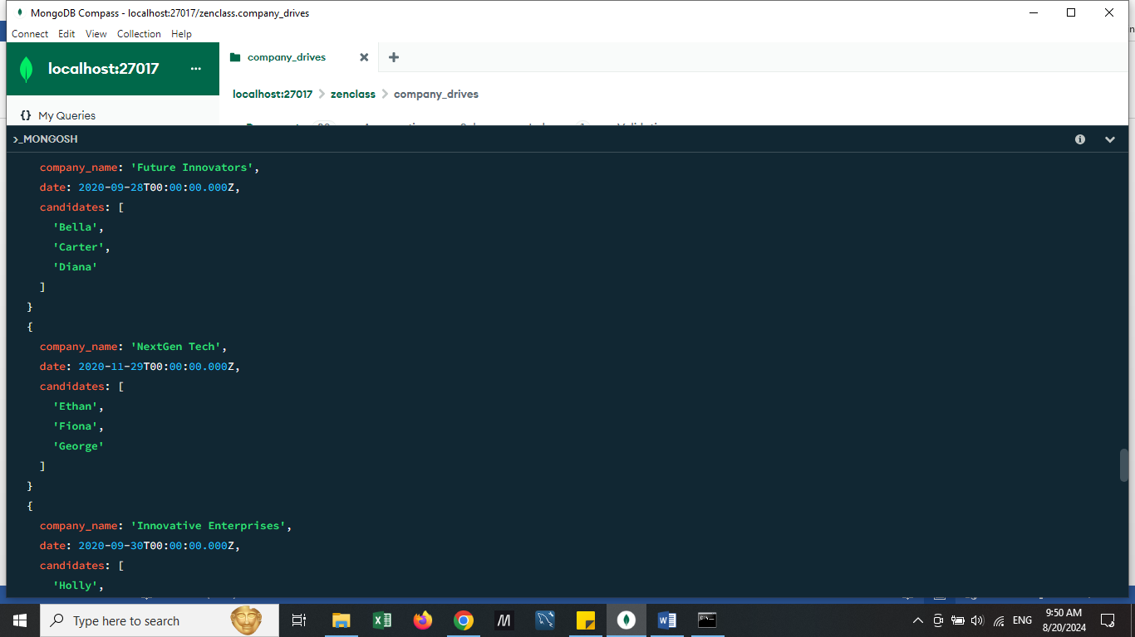 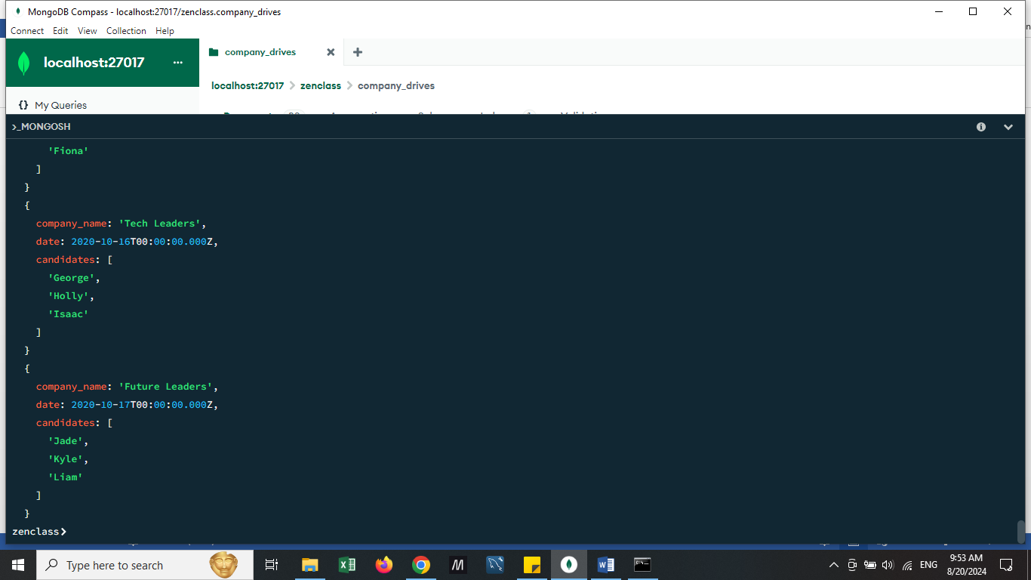

4) Find the number of problems solved by the user in codekata

collection: Codekata

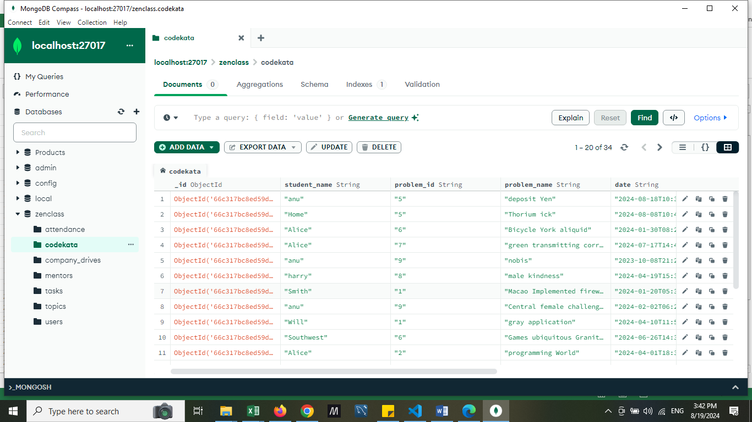

Query:

*db.codekata.find({student_name:"Alice"}).count();*

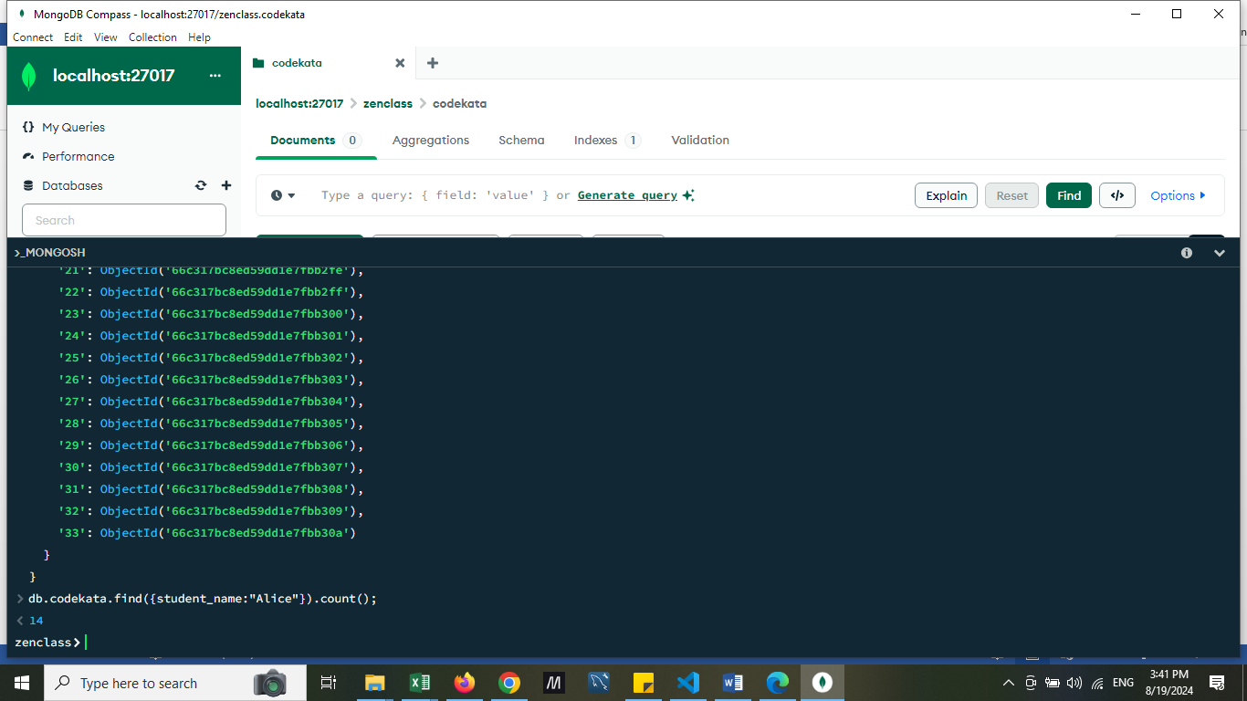

5)Find all the mentors with who has the mentee's count more than 15

Query :

*db.mentors.aggregate([*

*{*

*$group: {*

*_id: "$name",*

*uniqueStudentIds: { $addToSet: "$student_id" }*

*}*

*},*

*{*

*$project: {*

*name: "$_id",*

*count: { $size: "$uniqueStudentIds" }*

*}*

*},*

*{*

*$match: {*

*count: { $gte: 15 }*

*}*

*},*

*{*

*$project: {      _id: 0,      name: 1,      count: 1    }*

*}*

*])*

Results:

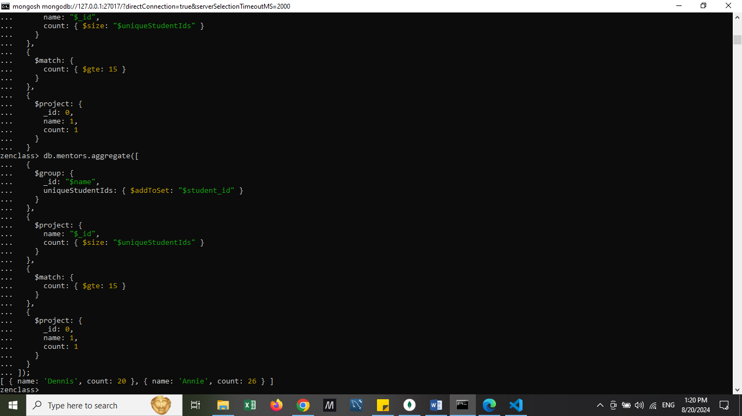

6)Find the number of users who are absent and task is not submitted between 15 oct-2020 and 31-oct-2020

zenclass> const taskSubmissionCursor = db.task_submissions.find({

submission_date: {

$gte: ISODate('2020-10-15'),

$lte: ISODate('2020-10-31')

}

}).map(doc => doc.student_id);

zenclass> const taskSubmissionStudentIds = [];

zenclass> while (taskSubmissionCursor.hasNext()) {

const doc = taskSubmissionCursor.next();

taskSubmissionStudentIds.push(doc.student_id);

}

4

zenclass> const attendanceCursor = db.attendance.find({

date: {

$gte: ISODate('2020-10-15'),

$lte: ISODate('2020-10-31')

},

present: false,

student_id: {

$nin: taskSubmissionStudentIds

}

});

zenclass> const absentStudentIds = [];

zenclass> while (attendanceCursor.hasNext()) {

const doc = attendanceCursor.next();

absentStudentIds.push(doc.student_id);

}

16

zenclass> printjson(absentStudentIds);

[

'4',

'8',

'4',

'8',

'8',

'6',

'8',

'4',

'6',

'8',

'4',

'8',

'8',

'8',

'4',

'8'

]

zenclass> const uniqueAbsentStudentIds = new Set(absentStudentIds);

zenclass> const distinctCount = uniqueAbsentStudentIds.size;

zenclass> print("Count of distinct student IDs:", distinctCount);

Count of distinct student IDs: 3

